Self-read - All Module

- McKinsey & Company – “The State of AI: Global Survey 2025”
- This survey shows how enterprises are using AI (88% report usage in at least one business function) and highlights workflow redesign, leadership ownership, talent strategy as key value drivers. McKinsey & Company
- Very relevant for framing the ‘waves of AI’ and the maturity gap.

the-state-of-ai-in-2025-agents-innovation-and-transformation.pdf

- Boston Consulting Group (BCG) – “How Generative AI Is Transforming Business”
- Explains difference between predictive AI and GenAI; emphasises people + processes over just algorithms. BCG Global
- Good fit for our sessions on prompting, LLMs, GANs, diffusion models.
https://www.bcg.com/capabilities/artificial-intelligence/generative-ai

- Deloitte – “Generative AI for Enterprises”
- Focuses on how and where GenAI should be used, risks, readiness factors. Deloitte
- Useful for our leadership & risk section.
us-ai-institute-gen-ai-for-enterprises.pdf

- Statworx – White-paper: “AI Strategy: A Guide to Development and Implementation in Three Steps”
- More foundational; good for understanding how to build an enterprise AI strategy at a high level.
EN-AI-Strategy-Whitepaper.pdf

- Gartner, Inc. – Enterprise Guide to Generative AI
- Focused on ROI, use-case selection, model choice — useful for Module 3 (model selection/data strategy) and also Module 2 (business value).
https://www.gartner.com/en/topics/generative-ai

🔍 Top Recent Sources
Articles and reports tied to enterprise AI strategy, LLM model developments (open & closed), and large-scale deployment challenges.
Source | Date | Why it matters
McKinsey & Company – “The State of AI: Global Survey 2025” | Nov 5 2025 (McKinsey & Company) | Shows 88% of organisations now using AI in a business function; includes agentic AI stats — excellent for Module 1’s framing of adoption & scale.
Gartner, Inc. – Enterprise Guide to Generative AI | Sept 2025 (Gartner) | Focused on ROI, use-case selection, model choice — useful for Module 3 (model selection/data strategy) and also Module 2 (business value).
Ernst & Young-Confederation of Indian Industry (CII) Report – Is India ready for Agentic AI? The AIdea of India: Outlook 2026 | Nov 16 2025 (The Economic Times) | Localised Indian context: 47% of Indian enterprises now have multiple GenAI use-cases live. Very useful for India-focused discussion or case emphasising regional maturity.
Capgemini – World Quality Report 2025 | Nov 13 2025 (Capgemini) | Reports nearly 90% of orgs pursuing GenAI in quality engineering but only 15% at scale. Great evidence for Module 3’s “scale vs pilot” topic.
Andreessen Horowitz (a16z) – How 100 Enterprise CIOs Are Building and Buying Gen AI | June 2025 (Andreessen Horowitz) | Focuses on enterprise choice between open vs closed models (e.g., LLaMA, Mistral) — directly relevant to your Module 3 model-strategy content.
Medium article – Open Source LLM Development 2025: Landscape, Trends & Insights | Oct/Nov 2025 (Medium) | Good for Module 2/3 on open-source vs proprietary models: market dynamics, developer ecosystem.
Technavio – Open-Source LLM Market Size 2025-2029 | 2025 forecast (Technavio) | Quantitative: open-source LLM market growth (CAGR ~33.7%) — helpful for Module 2 (monetisation/business models) reinforcing open-source value proposition.
Academic paper – Enterprise Architecture as a Dynamic Capability for Scalable and Sustainable Generative AI adoption | May 2025 (arXiv) | A strong academic source oriented to governance, architecture, scaling GenAI — excellent for advanced learners in Module 3.

Make.com - Hands-on

Examples
https://eu2.make.com/public/shared-scenario/gD7SZyfIsPr/customer-sentiment-analysis-sheets-l
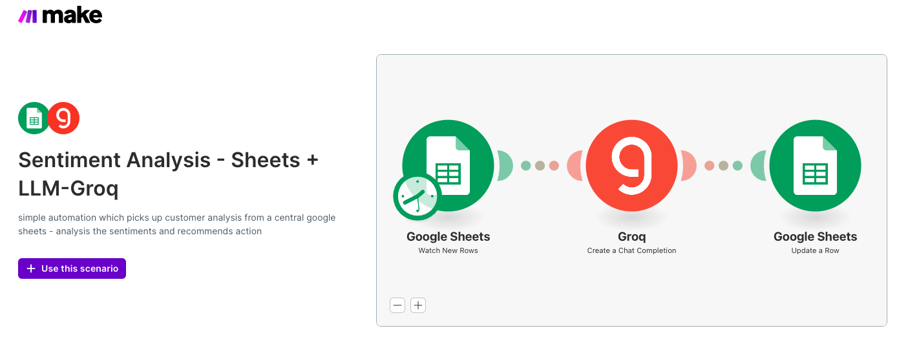

https://eu2.make.com/public/shared-scenario/aKRg7tGAB46/meeting-minutes-to-action-items-sheets
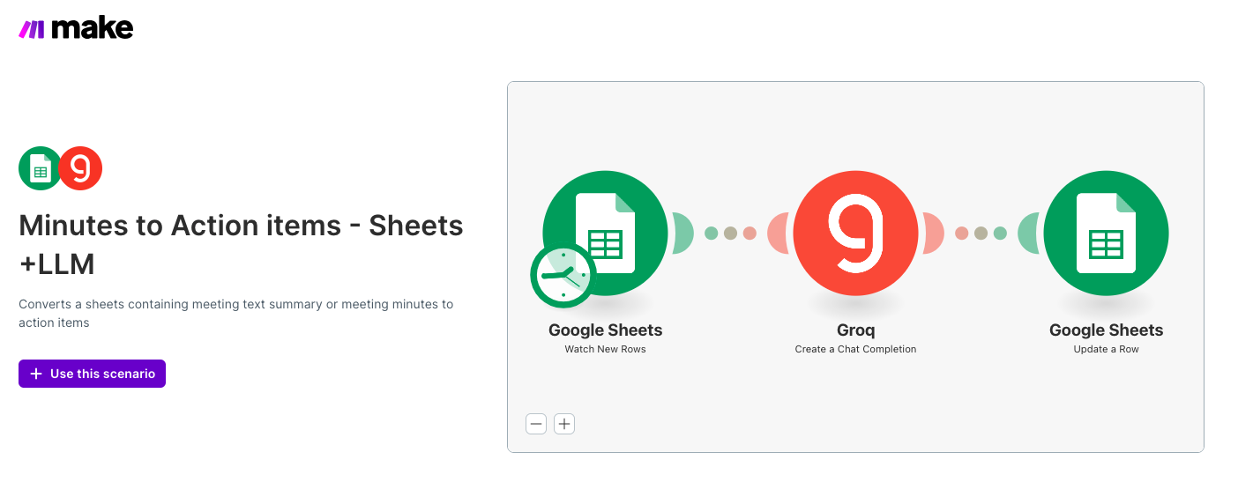

Data sheets and prompts

https://eu2.make.com/public/shared-scenario/jD8xusPe8jW/manufacturing-quality-inspection
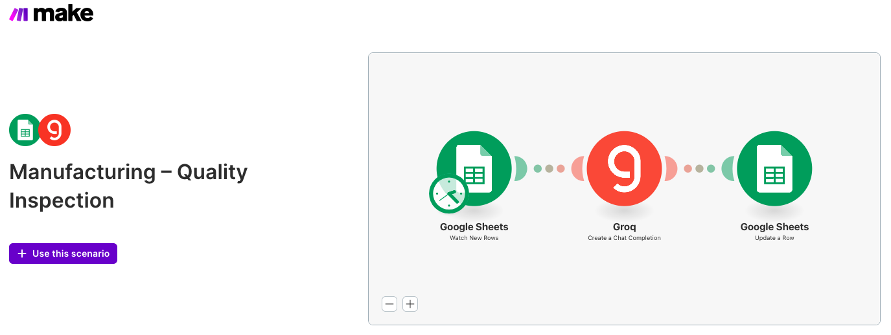

Quality Inspection_Manfacturing

You are a Quality Control Analyst.

Given defect logs:
1. Identify the top defects.
2. Estimate impact (downtime or cost).
3. Recommend corrective actions.
4. Flag critical machinery.

Output:
- Summary
- Top Defects
- Critical Issues
- Recommendations

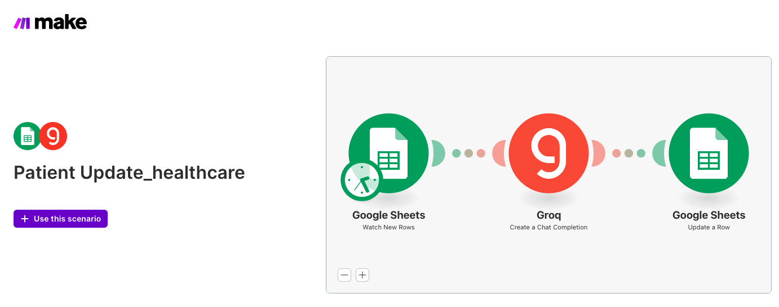

https://eu2.make.com/public/shared-scenario/ncLNecjMctT/patient-update-healthcare

HealthCare Patient Follow-up

You are a medical communication assistant.

Given the patient's symptoms and doctor notes:
1. Draft a simple, clear follow-up message.
2. Use empathetic tone.
3. Include next steps, warning signs, and when to contact a doctor.
4. Avoid medical over-claiming.

Output:
- Patient Message (100–150 words)

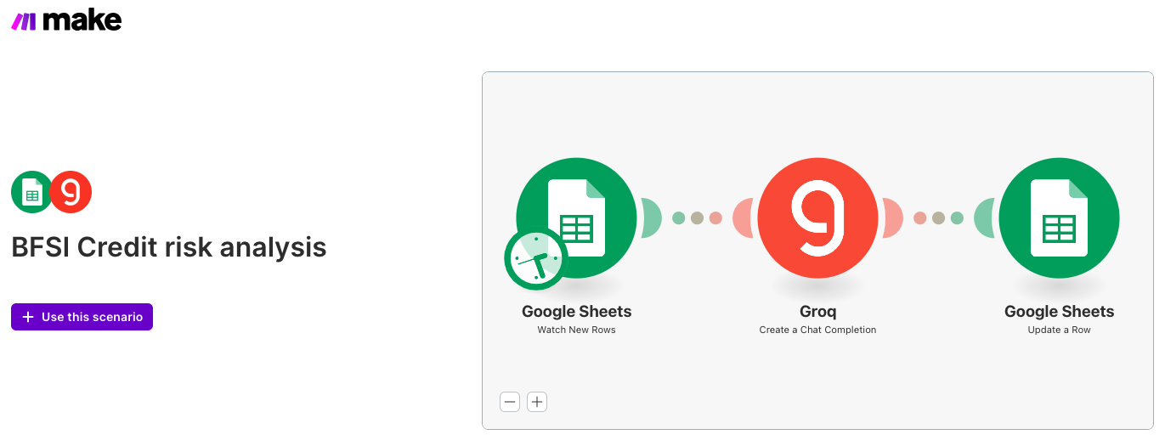

https://eu2.make.com/public/shared-scenario/kz4HTPIxKJr/bfsi-credit-risk-analysis

BFSI_Credit_risk_80Rows
You are a risk analyst for a bank.

Given structured customer data:
1. Determine overall credit risk (Low / Medium / High).
2. Explain drivers behind the score.
3. Flag risk indicators.
4. Recommend credit suitability or next steps.

Output format:
- Risk Category
- Key Risk Factors
- Risk Explanation
- Recommendation

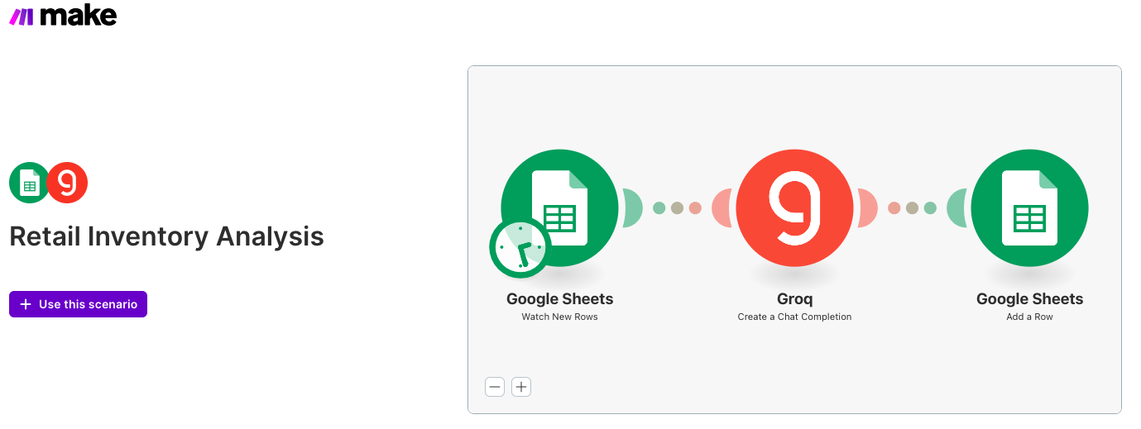
https://eu2.make.com/public/shared-scenario/YZRYo6ItHoe/retail-inventory-analysis

retail_inventory_mismatch_80Rows
You are a Retail Inventory Analyst.

Given a CSV of inventory_system_qty and physical_count_qty:
1. Identify mismatched SKUs.
2. Categorize mismatches as minor (<10 units), medium (10–50), or critical (>50).
3. Suggest potential root causes.
4. Generate a clean summary report with bullet points.

Output format:
- Summary
- Critical Mismatches
- Possible Causes
- Recommendations

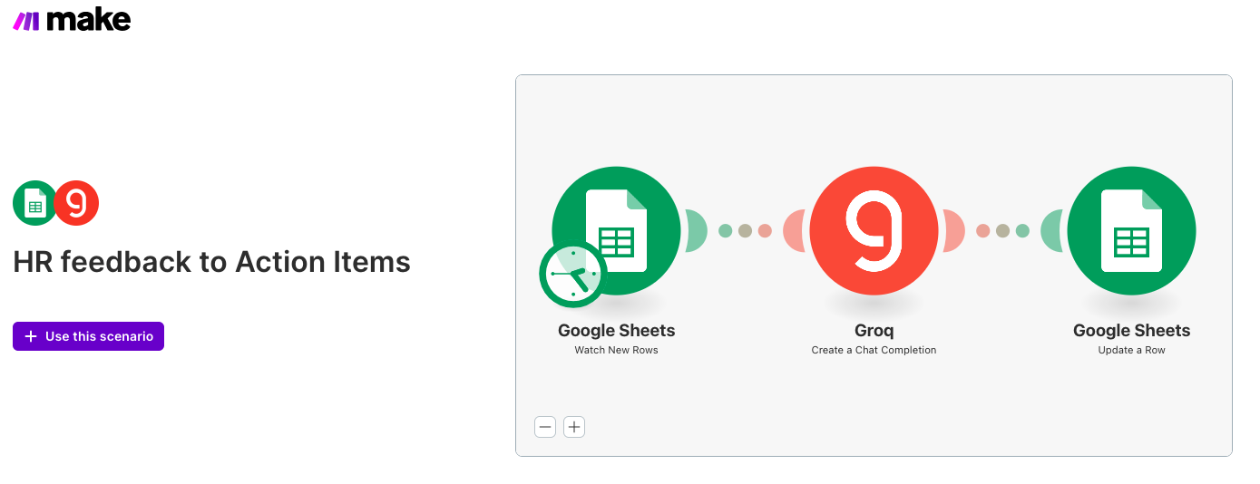
https://eu2.make.com/public/shared-scenario/5BD7sys7hk9/hr-feedback-to-action-items

HR_feedback
You are an HR Insights Analyst.
You receive a batch of anonymous employee comments as CSV text.

Your task:
1. Identify top sentiment categories (e.g., workload, manager issues, workplace culture, growth, clarity).
2. Summarize the themes.
3. Highlight risks (attrition, burnout, conflict).
4. Provide 5 actionable HR recommendations.
5. Keep responses clear, neutral, and evidence-based.

Output format:
- Summary
- Key Themes
- Risks
- Recommendations

Make.com resources for different domains solutions

https://www.make.com/en/templates

https://www.make.com/en/how-to-guides/task-automation

https://www.make.com/en/blog/marketing-automation-examples-2021

https://www.make.com/en/templates/12120-ai-tools-101-simple-auto-completion-with-openai-and-google-sheets

https://www.make.com/en/templates/12857-generate-images-with-openai-and-upload-files-to-google-drive?utm_source=chatgpt.com

Samples out there

🎯 Examples from Different Domains (That You Can Use Immediately)
Based on the sources above, here are concrete examples you could adapt for your batches or demos:
- Education / LMS — Automatic logging of learner data from an e-learning platform + personalized feedback generation + updating sheets. Medium
- Content / Digital Marketing — Automatically take a blog post → generate social posts + images (via OpenAI + image APIs) → post to multiple social channels. Make+1
- CRM / Sales Lead Automation — When a lead submits a form → auto-store in a sheet/CRM → send introductory email → schedule follow-up reminders. (Generic example from Make’s template library) Make+1
- E-commerce / Inventory — Template workflows for synchronizing spreadsheets, triggering reorder alerts, alerting stock mismatches, updating backend databases. (See Make’s Excel automation coverage.) Make+1
- Operations / Admin — Automating recurring tasks: form-to-sheet logging, report generation, file storage, notifications as per Make’s “50 tasks” guide. Make+1

✅ What’s Good / What to Watch Out For
Good:
- Templates + community flows give you a shortcut to working workflows — no need to build everything from scratch.
- Great way to experiment fast, test prompts/data pipelines, and iterate.
- Cross-domain coverage: from marketing to manufacturing, HR to education.
Watch out:
- Many shared templates are generic — may need customization for domain-specific data/logic.
- Data privacy, compliance, and access-control need careful review if using real data (especially in BFSI, healthcare).
- Some community templates may not be maintained (modules may update/block) — test thoroughly before using in training or client projects.

Build Ai Agents on make.com
https://academy.make.com/courses/ai-agents-foundationC06

Make.com Steps
Refer this document

https://docs.google.com/document/d/1Jio7__FefGZROb7xnYxDtoHodrULKbvBudvwtTTWh_I/edit?usp=sharing

Make.com: Practical Workflows
Refer the doc here
https://docs.google.com/document/d/1LvhfBUj_-kj3bz9DoB9hMb7293tgqljXmaNKxzVl4WQ/edit?usp=sharing

SLM - Module 1
Link to this document - Working Doc for Module 5

⭐ THE 7 CORE METHODS OF GENERATIVE AI (2024 → 2025 → 2026)
A leadership-ready breakdown

1. Prompt Engineering (The Original Core Method)
Status: Still essential, but now seen as the “base layer.”
Evolution since 2024:
- Prompt libraries
- Role-based prompting
- Function-calling prompts
- Chain-of-thought control (CoT, ToT suppression, guided reasoning)
Prompting evolved from “write better instructions” → designing controlled cognitive workflows.

2. RAG – Retrieval-Augmented Generation
Status: The dominant enterprise method (2024 → 2026)
Evolution since 2024:
- RAG 1.0 → RAG 2.0 → RAG Fusion models
- Multi-hop retrieval
- Structured RAG (tables, PDFs, SQL)
- “Graph RAG” using knowledge graphs
- “Query rewriting RAG” (improves retrieval quality)
We moved from “connect LLM to PDFs” → hybrid retrieval systems that mimic enterprise knowledge workers.

3. Fine-Tuning (still powerful but less used than RAG for enterprises)
Evolution since 2024:
- Parameter-efficient tuning (LoRA, QLoRA)
- Multi-modal fine-tuning
- RLHF & RLAIF pipelines
- Domain anchoring (e.g., MedPaLM, FinPaLM)
Enterprise shift:
Fine-tuning is now specialized, used for:
- brand tone
- compliance language
- domain reasoning
- agent behavior
But not the default.

4. Agents / Autonomous Orchestrators (The New Core Approach Post-2024)
This is the biggest new category.
Agents = Models that:
- plan
- decide
- take actions
- call tools
- monitor progress
- self-correct
Anthropic, OpenAI, Google, Meta introduced agent frameworks across 2024 → 2025.
These now have:

• Planning

• Reflection

• Memory

• Tool use

• Multi-step workflows
This is WHY enterprise GenAI shifted from “chatbots” → AI workers.

5. Tool-Use / Function-Calling Models (Core since mid-2024)
This category exploded with GPT-4o, Claude 3, Gemini 2.0.
LLMs can now:
- execute code
- call APIs
- control software
- run SQL
- trigger workflows (Make, Zapier, internal systems)
Tool-use became so integral that:
Every enterprise GenAI roadmap now considers function-calling a foundational capability.

6. Memory-Augmented Models (New 2025 Core Approach)
This is one of the most important evolution areas.
2024 → 2025 saw the emergence of:

✔ Persistent memory

✔ Session memory

✔ Long-term organizational memory

✔ Vector + episodic + declarative hybrid memory

✔ Agentic memory architectures
Transformers with 1M+ context windows changed everything.
Memory allows:
- multi-session personalization
- cumulative learning
- repeated task improvement
- “employee-like behavior”
Memory is now considered a core method because it transforms GenAI from “responding” → remembering + improving.

7. Multi-Modal Generation & Cross-Modal Reasoning
In 2024, multimodal = text + image.
In 2025, multimodal = everything:
- text
- image
- audio
- video
- code
- spatial data
- sensor data
- tabular data
- enterprise system logs
And all of it in one coherent reasoning loop.
This created:
- Visual RAG
- Audio-RAG
- Video-RAG
- Image reasoning
- Spatial understanding (for robotics, manufacturing)
You’ll see this strongly in corporate AI roadmaps from McKinsey, Google, OpenAI.

NVIDIA

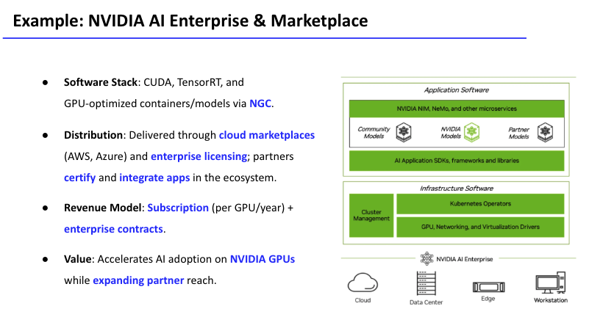

1. Software Stack: CUDA, TensorRT, GPU-optimised containers/models via NGC
What this really means:
- CUDA is NVIDIA’s parallel programming platform – the low-level layer that lets you run AI workloads on NVIDIA GPUs. NVIDIA Developer
- TensorRT sits on top; it’s an inference-optimisation SDK that takes trained models (from PyTorch, TF, etc.) and makes them run much faster and cheaper on NVIDIA GPUs by doing things like quantisation, fusion, kernel tuning, etc. NVIDIA Developer
- NGC (NVIDIA GPU Cloud) is a catalog/marketplace of pre-built containers, models and SDKs – PyTorch, TensorFlow, RAG stacks, NeMo, Triton Inference Server, etc. These containers bundle the whole user-space stack: CUDA libraries, cuDNN, TensorRT and the framework in one image. NVIDIA+2NVIDIA Docs+2
So: when the slide says “CUDA, TensorRT, and GPU-optimized containers/models via NGC”, it’s describing a full-stack, containerised AI platform where devs don’t have to assemble drivers, libraries and frameworks themselves – they just pull a certified container and go.

2. Distribution: cloud marketplaces + enterprise licensing; partners certify and integrate apps
How it’s actually distributed:
- NVIDIA AI Enterprise is sold via:
  - Cloud marketplaces – AWS, Azure, Google Cloud, OCI, etc., as VM images or on-demand offerings. NVIDIA+2NVIDIA Docs+2
  - NVIDIA Enterprise licenses / partner network – classic enterprise licensing through OEMs and system integrators. NVIDIA+1
- The NGC catalog itself is the hub from which customers and partners pull certified containers, models and SDKs; NVIDIA positions this as a way for partners to certify and publish their AI apps into the ecosystem. catalog.ngc.nvidia.com+2catalog.ngc.nvidia.com+2
So “distribution via cloud marketplaces and enterprise licensing” is basically:
Ship the same software stack through hyperscaler marketplaces + OEM/partner channels, and let partners layer their own apps/services on top of it.
That’s the “marketplace” angle

3. Revenue model: Subscription (per GPU/year) + enterprise contracts
What the money actually looks like (at a high level):
- NVIDIA AI Enterprise is sold as a subscription licence per GPU (or per cloud instance) for a fixed period, typically 1–5 years. Licensing docs explicitly state that one AI Enterprise subscription licence is required for each GPU (or instance) where it runs. page.adn.de+1
- In cloud marketplaces (AWS, Azure), it often shows up as usage-based pricing (e.g. per GPU-hour) with infrastructure billed separately by the cloud provider. Amazon Web Services, Inc.+2Microsoft Marketplace+2
So your slide’s “Subscription (per GPU/year) + enterprise contracts” is summarising:
• Per-GPU subscription licensing (on-prem or BYOL cloud)
• Usage-based consumption in cloud marketplaces
• Wrapped into larger enterprise deals with OEMs / hyperscalers.
It’s a classic “platform + subscription + consumption” hybrid.

4. Value: Accelerates AI adoption on NVIDIA GPUs while expanding partner reach
This is the strategic payoff:
- NVIDIA positions AI Enterprise as a cloud-native software platform that helps orgs “deploy AI anywhere – clouds, data centres, edge – with reliable, secure, scalable operations”, cutting time-to-market and infra complexity. NVIDIA+1
- NGC’s pre-optimised containers and models “simplify and accelerate development” by giving devs production-ready stacks they can run on-prem or in any major cloud. NVIDIA+1
From NVIDIA’s POV:
- More value on their GPUs → higher GPU demand and stickiness.
- Partners (ISVs, SIs, cloud providers) plug into the stack and sell their own solutions, but all of it still rides on NVIDIA GPUs + NGC/AI Enterprise.
So your last bullet is basically:
NVIDIA AI Enterprise reduces friction for customers to run AI on NVIDIA hardware AND gives partners a distribution/monetisation channel through certified apps and marketplaces.
That’s the business-model punchline you want learners to see:
it’s not “just software”; it’s a platform + marketplace + licensing + ecosystem play built to lock in the GPU base and share upside with partners.

SLM - Module 2
Module 2 – GenAI Business Models & Monetization

1. Introduction: Why GenAI Business Models Matter
Most enterprises today adopt AI, but very few manage to monetize it.
Key insights from industry research:
- 88% of companies use AI in at least one function (McKinsey).
- Only ~20–25% report measurable ROI.
- Most AI deployments remain assistive, not transformative.
- Real value comes when AI integrates into workflows, not when it is used as a stand-alone tool.
- AI is transitioning from a cost optimization tool → to a revenue-generating business model.
Module 2 explores how GenAI can create new value pools, new revenue models, and new competitive advantages.

2. AI as a Tool vs AI as a Business Model

AI as a Tool
- Used in isolation
- Enhances productivity but does not transform value
- Easy to imitate
- Limited commercial moat

AI as a Business Model
- Integrated deeply into workflows, products, and customer experiences
- Produces recurring, scalable revenue
- Creates defensibility via data, ecosystem, or automation
- Becomes part of the core value proposition
BCG: “Tools improve efficiency; business models create competitive separation.”

3. The Four Monetization Pathways

1. Proprietary Data → Data-as-a-Service (DaaS)
When a company has unique domain data, it can monetize it via:
- Fine-tuned models
- Analytics services
- APIs
- Premium knowledge products
Example: BloombergGPT monetizing financial text data.

2. Model/API Licensing (Consumption-Based GenAI)
Model access sold via:
- Per token
- Per inference
- Per GPU-hour
- Subscription tiers
Why it works:
Low friction, scalable, predictable for enterprise workloads.

3. Ecosystems & Marketplaces
Platforms that allow third parties to build on top of GenAI:
- Model marketplaces
- AI app stores
- Partner integrations
- Vertical AI stacks
Example: NVIDIA’s NGC marketplace, Azure OpenAI ecosystem.

4. Workflow-Embedded AI (The Sticky Model)
AI becomes invisible and lives inside the user's daily workflow:
- Developer IDE copilots
- CRM copilots
- Support ticket automation
- Legal drafting copilots
Gartner: Workflow-embedded AI has the highest enterprise retention and revenue longevity.

4. The 3-Question Business Model Test
To evaluate any AI idea:

1. Will someone pay for this?
Is there a clear willingness to pay?

2. Do we have a defensible asset?
Examples: proprietary data, industry expertise, domain workflows, distribution channels.

3. Is the usage repeatable and scalable?
Does the customer use it repeatedly?
Does value accumulate over time?
If the answer to any single question is no, the model is not monetizable.

5. AI Pricing Models

1. Subscription (SaaS)
- Predictable recurring revenue
- Works for copilots, assistants, platforms

2. Usage-Based Pricing (API/Compute)
- Standard for model providers (OpenAI, Anthropic)
- Scales with consumption

3. Data/Model Licensing
- B2B contracts
- Enterprise fine-tuning & data services

4. Freemium → Conversion
- Entry-level free tier
- Conversion to paid premium tier

5. Outcome-Based Pricing
- AI performs measurable work
- Customer pays for results, not usage
- Aligned with agentic AI revolution (2025+ trend)

6. Moat Creation in GenAI
GenAI is easy to copy technically — but hard to copy strategically.

Moats come from:

1. Proprietary Data
Most powerful moat — creates differentiated model behavior.

2. Workflow Depth
AI embedded deeply in operations becomes irreplaceable.

3. Ecosystem & Partnerships
Distribution through other software systems (ISVs, marketplaces).

4. Customisation
Fine-tuned or workflow-tuned AI → customer lock-in.

5. Trust Layer
Security, compliance, and governance make enterprise adoption sticky.

7. The Agentic AI Monetization Shift
Post-2024, AI is moving toward:

1. Autonomous task completion
Multi-step workflows (e.g., reporting, approvals, drafting).

2. Delegation
Enterprises want AI that does the work, not just helps.

3. Measured outcomes
Which enables:
- pay-per-ticket-closed
- pay-per-document-generated
- pay-per-transaction-audited
MIT & Anthropic both highlight that agentic AI is the next big revenue engine.

8. Building a Monetizable AI Product
To convert an idea → business model:

✔ Identify user pains

✔ Map to workflow

✔ Build a thin, working value slice

✔ Test willingness to pay

✔ Add pricing + packaging

✔ Build a repeatable distribution channel

✔ Iterate on user adoption patterns
Deloitte emphasizes:
“AI value scales only when organizational readiness + workflow redesign + governance mature together.”

9. Case Study Examples

1. GitHub Copilot
- Embedded in the developer IDE
- Subscription-based
- High retention due to workflow integration
- Network effect: team-level benefits

2. BloombergGPT
- Monetizes domain-specific data
- Provides premium analytics & insights

3. NVIDIA AI Enterprise
- Marketplace model
- Per-GPU licensing
- Partner ecosystem growth

4. Harvey AI (Legal Copilot)
- Workflow-embedded
- Enterprise licensing
- Vertical specialization

10. Key Takeaways
- AI is no longer the product — the workflow is the product.
- Monetization depends on:
data → model → workflow → pricing → ecosystem → scale
- The most successful AI businesses leverage:
  - proprietary data
  - domain workflows
  - agentic automation
  - enterprise-grade trust & governance

AWS reinvent 2025 references

🎯 Key re:Invent References (2024–2025) + Why They Matter
Reference / Session / Announcement | Why It Matters / What It Adds
“Agentic AI headlines at re:Invent 2025” (official AWS blog) | Confirms that 2025 is being pitched by AWS around agentic AI + enterprise-scale agents + full-stack AI deployment, aligning with your “agentic AI as monetizable workflow” narrative. Amazon Web Services, Inc.
AWS re:Invent 2025 – Keynotes + Innovation Talks catalog | Official list of sessions — helps you pick actual talks to reference when discussing infrastructure, governance, and AI agents at scale. reinvent.awsevents.com+1
Announcement of new AWS services at re:Invent 2025 (Nova 2 models, Bedrock AgentCore, Trainium UltraServers etc.) | Concrete proof that major cloud infra providers are heavy-investing in GenAI model hosting, custom models, inference & training infra — this supports your argument that infrastructure + model + data + workflow ≡ monetizable AI stack. About Amazon+2About Amazon+2
“Architecture Patterns for GenAI at Enterprise Scale” (re:Invent 2024/2025) | Use this as technical credibility when discussing enterprise readiness — data pipelines, model lifecycle, orchestration, governance. Amazon Web Services, Inc.+1
Sessions on secure, privacy-first GenAI & compliance (e.g. CMP410 — Secure GenAI using trusted execution environments at re:Invent 2025) | Important to tie into your slides on trust, governance, compliance — especially when teaching enterprise AI monetization to risk-sensitive industries. Amazon Web Services, Inc.+1
AWS Marketplace + AI-powered agent ecosystem announcements (2025) | Demonstrates real-world momentum for ecosystem + marketplace + distribution + licensing — a core pillar of your “differentiation + monetization” framework. GeekWire+1
Re:Invent 2025 thematic shift — “Agents, not just AI Tools” | This supports your teaching point that GenAI value lies in automation, delegation, agentic workflows — not just in API calls or chat interfaces. TechCrunch+2About Amazon+2

n8n self-host
Self-hosting n8n is best done using Docker Compose, as it packages n8n and its dependencies (like the database) into isolated, manageable containers. This guide focuses on a robust Docker Compose setup, which is ideal for both local testing and deployment to a remote server.

⚙️ Prerequisites
Before you start, you'll need the following:
- A Server/System: A Virtual Private Server (VPS) running Linux (like Ubuntu) is ideal for 24/7 reliability.
- Minimum Requirements: At least 1 vCPU core, 2 GB of RAM, and 20 GB of SSD storage for basic use. For production, aim for 2-4 vCPU cores and 4-8 GB of RAM.
- Docker & Docker Compose: Both must be installed on your system.

🚀 Step 1: Prepare the Environment
You need a dedicated folder to hold your configuration files and a persistent directory for n8n's data.
Create a Directory:
mkdir n8n-stack
cd n8n-stack

Create a Data Volume Folder: This folder will hold all your workflows, credentials, and settings.
mkdir n8n_data

📝 Step 2: Create the Docker Compose File
A docker-compose.yml file defines how your n8n container should run, including which ports to use and what data to save. For production, you should use an external database like PostgreSQL instead of the default SQLite (which is unreliable for high-volume use).

Docker Compose Example (docker-compose.yml)
Create the file and paste the following content:
YAML
version: '3.7'

services:
n8n:
image: n8nio/n8n:latest
container_name: n8n
restart: always
ports:
- "5678:5678"
environment:
# --- IMPORTANT SECURITY SETTINGS ---
- N8N_HOST=localhost # Change this to your domain/IP later
- N8N_PROTOCOL=http # Change this to https once you set up a reverse proxy
- N8N_BASIC_AUTH_ACTIVE=true
- N8N_BASIC_AUTH_USER=n8nuser
- N8N_BASIC_AUTH_PASSWORD=a-secure-password # <-- CHANGE THIS
- N8N_ENCRYPTION_KEY=a-random-32-char-string # <-- CHANGE THIS
# --- DATABASE CONFIG (RECOMMENDED) ---
- DB_TYPE=postgresdb
- DB_POSTGRESDB_HOST=postgres
- DB_POSTGRESDB_DATABASE=n8n
- DB_POSTGRESDB_USER=n8n
- DB_POSTGRESDB_PASSWORD=a-secure-db-pass # <-- CHANGE THIS
- DB_POSTGRESDB_PORT=5432
volumes:
# Persists workflows, credentials, and settings
- ./n8n_data:/home/node/.n8n
depends_on:
- postgres

postgres:
image: postgres:14
container_name: postgres
restart: always
environment:
- POSTGRES_USER=n8n
- POSTGRES_PASSWORD=a-secure-db-pass # <-- MUST MATCH N8N SERVICE
- POSTGRES_DB=n8n
volumes:
# Persists the database content
- postgres_data:/var/lib/postgresql/data

volumes:
postgres_data:

⚠️ Critical Security Edits (Do NOT Skip)
Before running, you must edit the following environment variables in the file:
- N8N_BASIC_AUTH_USER / N8N_BASIC_AUTH_PASSWORD: Set your login credentials.
- N8N_ENCRYPTION_KEY: A long, unique, random string (32 characters or more) used to encrypt credentials stored in the database.
- DB_POSTGRESDB_PASSWORD: Set a secure password for the database.

▶️ Step 3: Run and Access n8n
Start the Containers: Run the following command from the n8n-stack directory where your docker-compose.yml file is located:
Bash
docker compose up -d
- (This pulls the images, creates the database, starts n8n, and runs them in the background.)
- Access the UI:
  - Locally: Open your web browser and navigate to http://localhost:5678.
  - On a Remote Server: Open your web browser and navigate to http://YOUR_SERVER_IP_ADDRESS:5678.
- Initial Setup: You will be prompted to enter the Basic Auth credentials you set (n8nuser and a-secure-password), and then you will create your first administrative user account.

🔒 Step 4: Secure with HTTPS (Essential for Production) - not required if you are just learning….
If you plan to use webhooks or OAuth credentials (like Google/Slack), you MUST run n8n over HTTPS.
- Set up a Domain: Point a domain name (e.g., n8n.mydomain.com) to your server's IP address.
- Install a Reverse Proxy: Use a tool like NGINX Proxy Manager (Docker-based) or Caddy to handle SSL/TLS certificate creation (via Let's Encrypt) and forward traffic securely from port 443 to n8n's internal port 5678.
- Update Environment Variables: Once the proxy is set up, you must edit your docker-compose.yml to reflect the change:
  - N8N_HOST: n8n.mydomain.com
  - N8N_PROTOCOL: https
  - WEBHOOK_URL: https://n8n.mydomain.com/
This guide on How to Set Up n8n with Docker Compose & Portainer is relevant as it walks through using Docker Compose for setup. ( LOOK ON YOUTUBE)

Module 2 activity Scenarios
Module 2 activity Scenarios

🟦 Scenario 1 — BFSI (Banking / Financial Services)
A leading retail bank is seeing rising credit losses and slower loan approvals. Competitors are adopting AI-driven underwriting, and the board wants to launch a new GenAI-powered product that can unlock a $100M revenue opportunity within 2–3 years.
The product must target either retail lending, SME lending, wealth management, or fraud/risk operations.

🟩 Scenario 2 — Retail & E-commerce
A national retail chain with both online and offline stores is facing profitability challenges due to stock-outs, markdown losses, and unpredictable customer demand. Leadership has approved a mandate to build a GenAI-driven retail solution that can be commercialized across the entire industry and generate $100M+ ARR within 3 years.

🟧 Scenario 3 — IT / Technology / SaaS
A mid-sized IT services and software engineering company wants to move beyond services and create a GenAI-powered product that improves developer productivity, reduces operational overhead, or transforms DevOps and cloud operations. The CEO expects the product to create a new scalable non-linear revenue stream in the next few years.

🟪 Scenario 4 — Manufacturing
A global manufacturing enterprise with multiple factories is struggling with high downtime, inconsistent product quality, and increasing maintenance costs. The organization believes it can commercialize a GenAI-based industrial intelligence product for other manufacturers and unlock a significant new revenue line beyond traditional manufacturing output.

🟥 Scenario 5 — Sales & Marketing (B2B)
A B2B SaaS company wants to enhance sales efficiency and increase pipeline generation using AI. The board has requested a GenAI commercial product that can be sold to other enterprises to improve revenue workflows — from lead research to proposal creation to deal forecasting — with a projected $100M revenue potential globally.

🚀 Scenario 1 — BFSI (Banking, Financial Services & Insurance)

Context
A large retail bank is facing declining customer engagement and rising operational costs. The board wants a $100M GenAI revenue-generating line within 3 years.

1. WHAT – Product & Customer
GenAI Credit Decisioning & Risk Automation Platform
Automates loan underwriting, risk scoring, fraud checks, and documentation.
Customer:
Banks, NBFCs, microfinance institutions, fintech lenders.

2. WHY BUY – Differentiation
Pick ONE defensible moat:
Proprietary Data Moat:
Uses 15 years of anonymized lending patterns, delinquency signatures, fraud profiles — unavailable to competitors.
Workflow Embedding:
Integrated into LOS, core banking, CRM, and regulatory reporting systems.

3. HOW – Monetization
- Usage-Based API — per credit file evaluated
- Outcome-Based Pricing — % of delinquency reduction
- Enterprise Licensing for regulatory compliance modules

4. WHY US – Go-to-Market
- Beachhead Customer: Mid-sized digital-first bank with high underwriting cost.
- 90-Day Experiment: Automate 30% of underwriting → measure turnaround time.
- CFO Metric: Reduction in cost-per-loan + increase in approval throughput.

🛍️ Scenario 2 — Retail & E-commerce

Context
A national retail chain wants to improve margins and reduce stock-outs using GenAI.

1. WHAT – Product & Customer
AI Merch Ops Copilot
Automates demand forecasting, product recommendations, visual merchandising optimization, and inventory balancing.
Customer:
Retail chains, supermarkets, e-commerce platforms.

2. WHY BUY – Differentiation
Proprietary Data:
SKU movement + regional demand trends + competitor pricing patterns.
Workflow Embedding:
Lives inside POS, WMS, ERP, and supply chain systems.

3. HOW – Monetization
- SaaS Subscription: per store/per category manager
- Revenue Share: % uplift in sell-through
- Marketplace Add-On: integrations with Shopify/BigCommerce

4. WHY US – Go-to-Market
- Beachhead Customer: Apparel chain with high SKU volatility.
- 90-Day Experiment: Optimize 15 categories → validate margin uplift.
- CFO Metric: Reduction in stock-outs + improved GMROI.

💻 Scenario 3 — IT / Technology / SaaS

Context
A mid-sized IT services company wants to productize GenAI and create new non-linear revenue.

1. WHAT – Product & Customer
AI DevOps Autopilot
Automates code review, deployment pipelines, test case generation, security scans, and incident summaries.
Customer:
Tech companies, SaaS firms, DevOps teams, managed service providers.

2. WHY BUY – Differentiation
Workflow Embedding:
Direct plug-ins for GitHub, GitLab, Jira, Jenkins, Terraform, Kubernetes.
Performance at Scale:
99.5% precise defect detection using proprietary code patterns from previous client projects.

3. HOW – Monetization
- Seat-Based SaaS: per developer
- Usage-Based API: per deployment pipeline
- Enterprise Contract: self-hosted edition for regulated industries

4. WHY US – Go-to-Market
- Beachhead Customer: SaaS firm struggling with release delays.
- 90-Day Experiment: Reduce cycle time from 14 days → 6 days.
- CFO Metric: Cost saved per sprint + reliability gain.

🏭 Scenario 4 — Manufacturing

Context
A global automotive component manufacturer needs AI-driven factory intelligence.

1. WHAT – Product & Customer
AI Quality & Predictive Maintenance Copilot
Analyzes QC reports, sensor data, defect patterns; predicts failures; auto-recommends maintenance schedules.
Customer:
Factories, industrial machinery companies, automotive suppliers.

2. WHY BUY – Differentiation
Proprietary Data:
10 years of vibration/temperature profiles + defect logs from machinery across multiple plants.
Agentic Automation:
Automatically creates work orders, assigns technicians, and updates SAP/MES.

3. HOW – Monetization
- Subscription: per machine/per line
- Outcome-Based: % reduction in downtime
- API: anomaly detection + defect classification endpoints

4. WHY US – Go-to-Market
- Beachhead Customer: Tier-2 auto-parts supplier operating 4–8 production lines.
- 90-Day Experiment: Reduce downtime by 12–18%.
- CFO Metric: Cost savings from avoided stoppages.

📣 Scenario 5 — Sales & Marketing

Context
A B2B SaaS company wants to boost revenue efficiency using GenAI.

1. WHAT – Product & Customer
AI Revenue Intelligence Copilot
Automates lead qualification, proposal drafting, account research, competitor analysis, and deal scoring.
Customer:
B2B SaaS, enterprise sales teams, consulting firms.

2. WHY BUY – Differentiation
Workflow Embedding:
Lives inside HubSpot, Salesforce, Gmail/Outlook, LinkedIn Sales Navigator.
Data Moat:
Learns from each organization’s internal deal cycles, win/loss notes, and ICP patterns.

3. HOW – Monetization
- SaaS: per user/per sales rep
- Revenue Share: % share of incremental pipeline created
- Freemium Tier: basic research → paid for proposal automation

4. WHY US – Go-to-Market
- Beachhead Customer: fast-growing SaaS with >20 reps.
- 90-Day Experiment: increase qualified pipeline by 25%.
- CFO Metric: cost per qualified lead vs. uplift in ARR.

SLM - Module 3

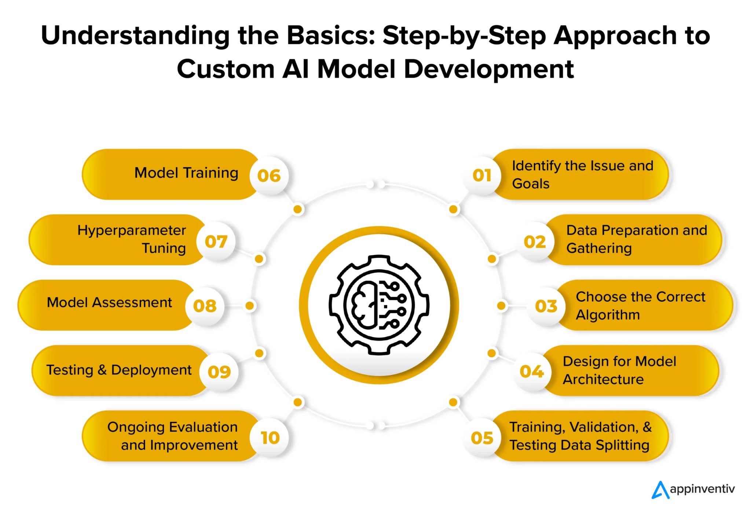
This slide is the bridge between:
- experimentation (Module 1)
- monetization (Module 2)
- enterprise scale (Module 3)

How Customization Works – What This REALLY Means in Enterprise GenAI
This diagram represents the full lifecycle of customizing AI systems.
In GenAI, this is not a one-time build exercise — it’s a continuous operating model.

01. Identify the Issue and Goals
What people think this is:
“Let’s build a chatbot / copilot / AI assistant.”
What it actually is:
- What decision, task, or workflow is broken?
- Who is accountable for the outcome?
- What business metric will change if this works?
Enterprise reality:
Most GenAI failures start here because goals are vague:
- “Improve productivity”
- “Use AI in support”
Better framing:
- Reduce average handling time by 20%
- Cut escalations by 30%
- Improve first-response accuracy to 95%
👉 In GenAI, clarity of intent matters more than model choice.

02. Data Preparation and Gathering
What people underestimate:
This is 60–70% of the effort, not 10%.
In enterprise GenAI, data includes:
- Documents (PDFs, emails, SOPs)
- Logs, tickets, transcripts
- Policies, contracts, manuals
- Structured + unstructured data together
Key GenAI shift:
You’re not just collecting data — you’re creating context.
Bad data → hallucinations
Incomplete data → confident nonsense
👉 This is where RAG pipelines, document chunking, metadata tagging, and access control live.

03. Choose the Correct Algorithm
This step has changed the most since GenAI.
Old thinking:
“Pick the best algorithm.”
New thinking:
“Pick the right pattern.”
Examples:
- Retrieval-heavy tasks → RAG + foundation model
- Style/format consistency → fine-tuning
- Multi-step workflows → agents + orchestration
- High-risk decisions → hybrid (rules + AI)
Enterprise truth:
Most systems use multiple algorithms, not one.
👉 Model choice follows the task — not the other way around.

04. Design for Model Architecture
This is not just “model architecture” anymore.
It includes:
- Orchestration (chains, agents, tools)
- Memory (short-term vs long-term)
- Tool access (APIs, databases, workflows)
- Guardrails (filters, validation, fallbacks)
Modern GenAI architecture =
Model + Context + Tools + Control
This is where platforms like:
- AWS Bedrock
- LangChain
- n8n / Make
- Vector databases
come into play.
👉 This is the difference between a demo and a production system.

05. Training, Validation & Testing Data Splitting
In GenAI, this step often confuses teams.
Key distinction:
- For RAG → you’re validating retrieval quality, not training the model
- For fine-tuning → classic train/validate/test applies
- For agents → you test decision paths and failure modes
Enterprise focus shifts from:
Accuracy → Reliability, consistency, and bounded behavior
👉 “Wrong but confident” is worse than “not answered”.

06. Model Training
Only a subset of enterprise GenAI systems actually do this.
When training makes sense:
- Domain-specific language (legal, medical, finance)
- Repetitive structured outputs
- Strong data governance
When it doesn’t:
- Generic Q&A
- Rapidly changing knowledge
- Early-stage pilots
Reality check:
Most enterprises over-train too early.
👉 Fine-tuning is a strategic investment, not a default step.

07. Hyperparameter Tuning
In classic ML this was central.
In GenAI, it’s selective and contextual.
You tune:
- Temperature (creativity vs determinism)
- Max tokens (cost + verbosity)
- Retrieval depth (recall vs noise)
- Agent timeouts and tool limits
Why it matters:
This is how you control:
- Cost
- Latency
- Output stability
👉 This is where GenAI becomes operationally viable.

08. Model Assessment
This is not accuracy testing alone.
Enterprise GenAI assessment includes:
- Hallucination rate
- Consistency across similar inputs
- Bias and fairness
- Compliance alignment
- Human override effectiveness
Key shift:
Evaluation is often human-in-the-loop, not automated.
👉 Enterprises care more about trustworthiness than brilliance.

09. Testing & Deployment
Deployment is where most pilots die.
Why?
- No rollback strategy
- No monitoring
- No access control
- No audit logs
Production-grade GenAI requires:
- Canary releases
- Prompt/version control
- Cost monitoring
- Failure handling paths
👉 Deployment is not “go live”; it’s “go live safely”.

10. Ongoing Evaluation and Improvement
This is the most important step — and the most ignored.
GenAI systems:
- Drift as data changes
- Break when workflows evolve
- Get misused by users
Continuous improvement includes:
- Prompt updates
- Knowledge refresh
- Model switching
- Policy updates
- Feedback loops
Modern view:
GenAI systems are living systems, not finished products.

Key Findings - 10

Here are 10 up-to-date, high-impact key findings from recent enterprise AI/GenAI research (including OpenAI’s State of Enterprise AI 2025, McKinsey’s State of AI: Global Survey 2025, agentic AI market trends, and other recent data points from the last 3–4 months).

1. Enterprise AI Usage Is Rapidly Scaling
Over 1 million businesses now actively use AI tools, and enterprise usage has grown dramatically — with ChatGPT message volume up 8× and API reasoning tokens consumed per organization up 320× year-over-year, indicating deeper workflow integration. OpenAI

2. GenAI Is Becoming Core Infrastructure
Enterprises are moving beyond experimentation — AI is increasingly treated as a critical part of core operations, not just a point solution. This trend is likened to major historical shifts in enterprise technology adoption (e.g., cloud). ALM Corp

3. Productivity Gains Are Observable
Workers report saving 40–60 minutes per day using AI tools such as ChatGPT in professional contexts, contributing to operational productivity improvements across teams. ALM Corp

4. Adoption Is Broad but Benefits Vary
Nearly 88% of organizations report AI use in at least one business function, but only a minority have deeply scaled these deployments into transformed workflows. McKinsey & Company

5. Redesigning Workflows Drives Value
High-performing organizations are three times more likely to redesign workflows around AI, and this practice is strongly linked to achieving measurable business impact. McKinsey & Company

6. Leadership Commitment Matters
Senior leadership ownership and engagement are key differentiators; organizations with strong executive buy-in are far more likely to scale AI and embed it into strategy. McKinsey & Company

7. Enterprise AI Still Faces the Pilot-to-Scale Gap
Despite broad experimentation, deep deployment remains rare. Research shows a dramatic drop from pilot activity to production deployments, with only 5% of custom tools moving to meaningful enterprise impact. MLQ

8. “The GenAI Divide” Persists
Most industries (7 of 9 examined) exhibit high adoption but low structural transformation, indicating that generic GenAI tools often fail to deliver structural change without workflow integration and learning systems. MLQ

9. Agentic AI Adoption Is Growing Fast
Agentic AI — systems capable of autonomous multi-step task execution — is increasingly embraced: enterprise agent adoption is accelerating, with forecasts suggesting widespread deployment and strong investment. Expectations include significant operational cost reductions and high projected ROI. Wikipedia

10. ROI and Risk Are Uneven Across Enterprises
While many enterprises invest heavily, measurable ROI still lags for a large share of AI pilots, and challenges such as data readiness, integration friction, and governance continue to be top barriers; MIT research points to high failure rates for pilots without enduring value. Fortune+1

